Lesson 11 – CSS Box Model

**CSS Box Model:**

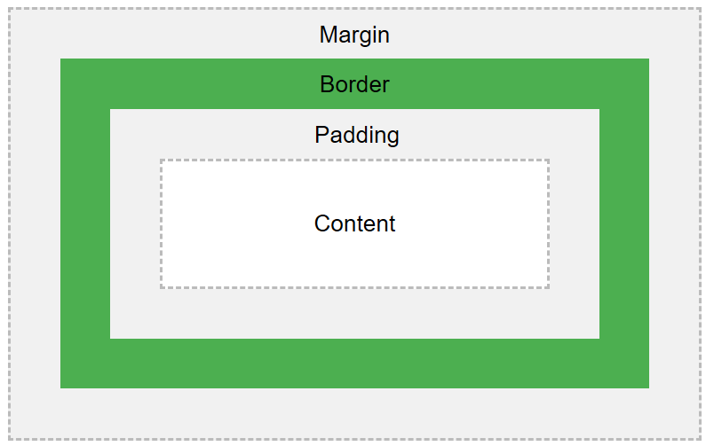

* read and try: <https://www.w3schools.com/css/css_boxmodel.asp>
* complete the exercises: [[1]](https://www.w3schools.com/css/exercise.asp?filename=exercise_boxmodel1), [[2]](https://www.w3schools.com/css/exercise.asp?filename=exercise_boxmodel2), [[3]](https://www.w3schools.com/css/exercise.asp?filename=exercise_boxmodel3), [[4]](https://www.w3schools.com/css/exercise.asp?filename=exercise_boxmodel4)

**Task:**

* Finish the upgrade of **your website** by moving all **CSS** declarations to the **external stylesheet**.

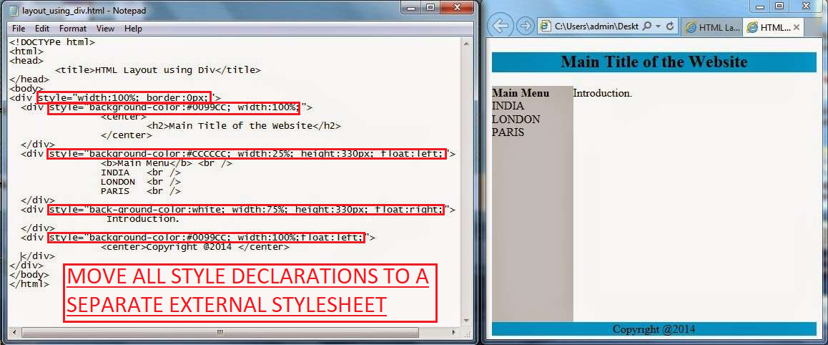

*Optional practice:*

* *CSS* *Borders*: <https://www.w3schools.com/css/css_border.asp> + exercises
* *CSS* *Margins*: <https://www.w3schools.com/css/css_margin.asp> + exercises
* *CSS* *Padding*: <https://www.w3schools.com/css/css_padding.asp> + exercises
* *CSS* *Dimensions*: <https://www.w3schools.com/css/css_dimension.asp> + exercises
* *CSS Calc Function*: <https://www.w3schools.com/cssref/func_calc.asp> (*when may it be useful?*)